Author : Orion Raysher Lee

Admin No. : 190455P

Module Group : IT2554-03

Content:

1. Installation Guide

2. Troubleshoot

App is running on

* Google Chrome
* PyCharm Edu 2020.1
* Python 3.8
* Flask 1.1.2
* Pycryptodome 3.9.7

Note: This installation guide assumes you have PyCharm and Python 3.x installed into your computer. If after following the installation guide and that it did not work, please update PyCharm to 2020.1 and Python to 3.8

Installation

1. This is what you should see when first extracting 3-Orion Raysher Lee.zip

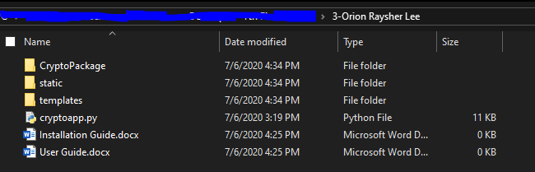

2. Open up PyCharm and create a new project at this file location

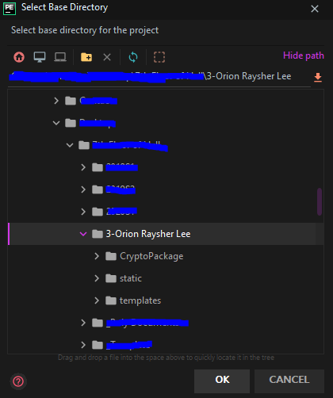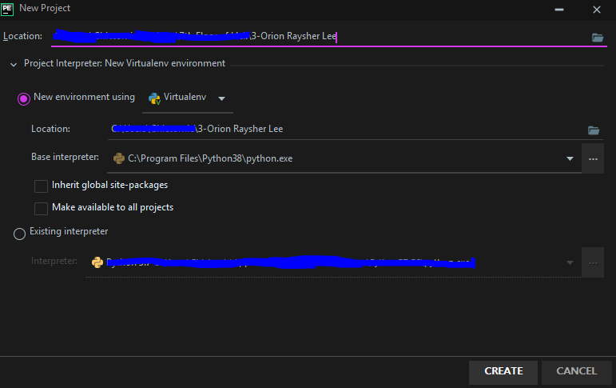

2b. If this pops up, click “No”.

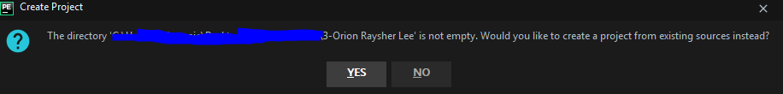

When you open the terminal (found at bottom-left of Pycharm) and type “pip list” u should see this :

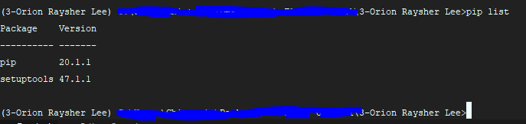

3. From your terminal, type in “pip install Flask”

Now when you type in “pip list” u should see :

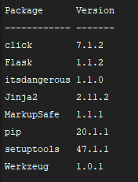

4. From your terminal, type in “pip install pycryptodome”:

Now when you type in “pip list” u should see :

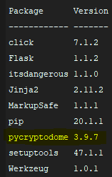

5. From PyCharm, under project directories (left side), right click cryptoapp.py and run it

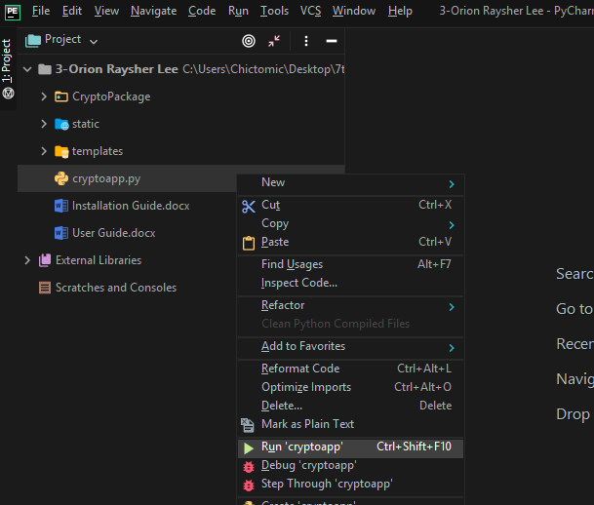

5b. It should run normally but if this error occurred while running, refer to the troubleshoot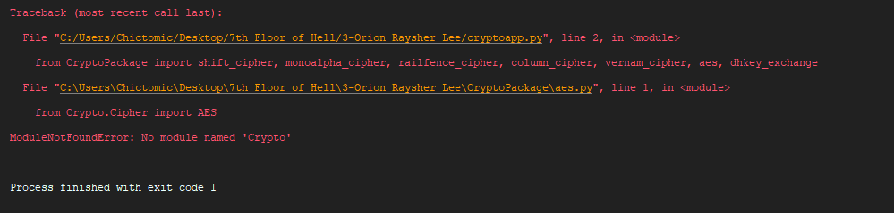

6. If it is working correctly, you should see this. Click on the http link and you have run it successfully!

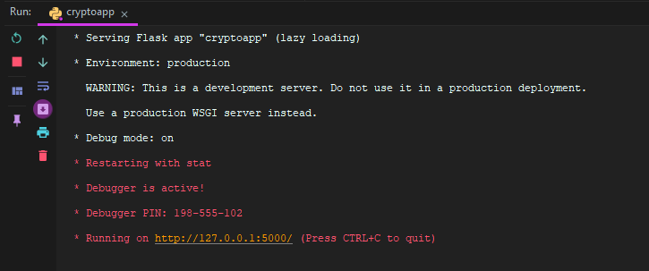

This is what you should see when you click on <http://127.0.0.1:5000/>

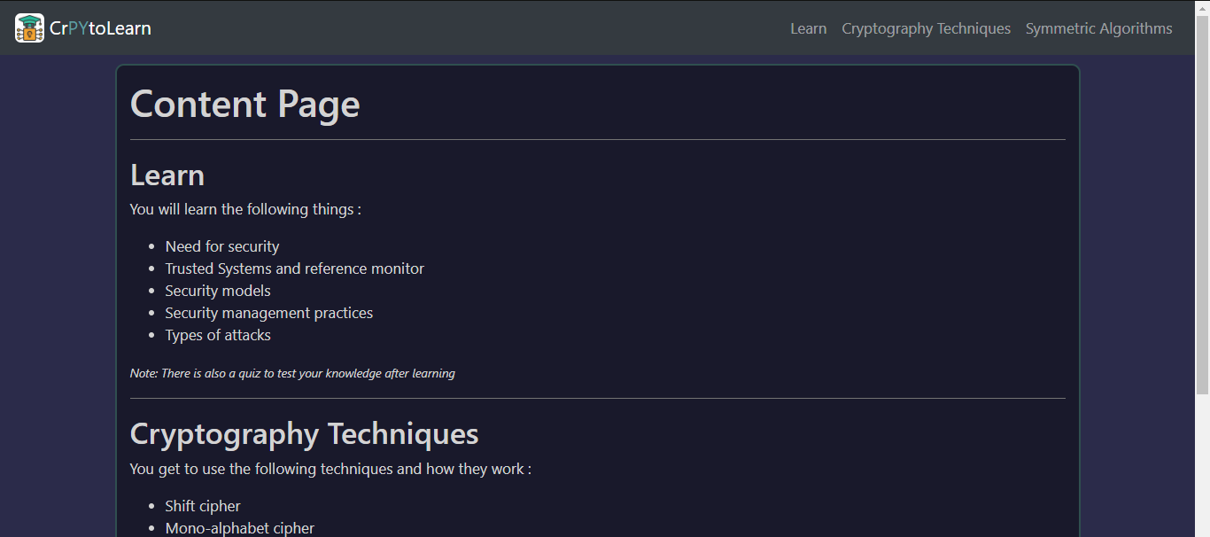

Refer to user guide to find out about (Recommended)

* Code structure (where to find pieces of code)
* Navigating through the web application
* Inputs accepted for each cryptography techniques and algorithms

Troubleshoot

1. From PyCharm, go to External Libararies 🡪 <Python 3.x (3-Orion Raysher Lee) > 🡪 site-packages

2. Look for this file called “crypto”

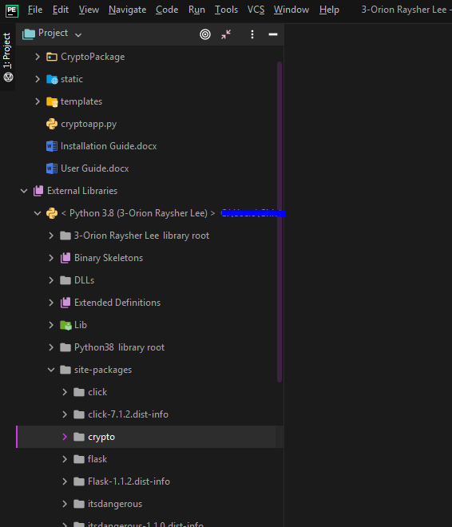

3. Refactor (rename) it to “Crypto” with a capital ‘C’

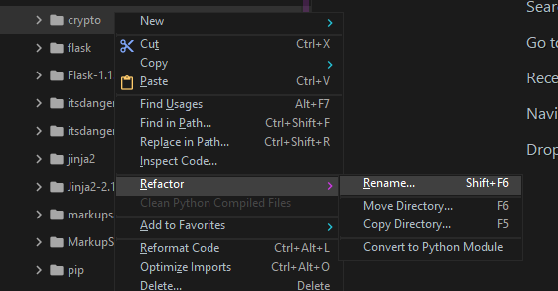

3b. Click “yes” and rename it to “Crypto”

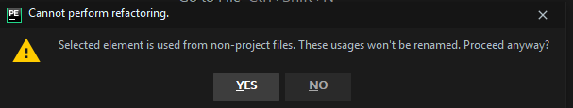

You should see this and try following step 5 of installation guide again.

